
Year 9

Mini Test 1

Area, Surface Area and Volume

Total Marks: 33 marks
Name: ______________________ Total Time: 35 minutes

Show working and answers on this sheet. Show working in sufficient detail to support your answers. Incorrect answers without supporting reasoning may be allocated zero marks.
Resources Allowed – 1 A4 Page (2 Sides) of Notes, Calculator

Question 1 3 marks
Convert the following units:

- 23mm = __________ cm

- 0.00032m² = __________ cm²

- 1.2m³ = ___________cm³

Question 2 11 marks
Find the area of the following. Give answer to 1 decimal place.

[2 Marks]

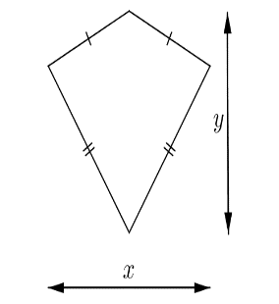

7 km
5 km

[2 Marks]

c.
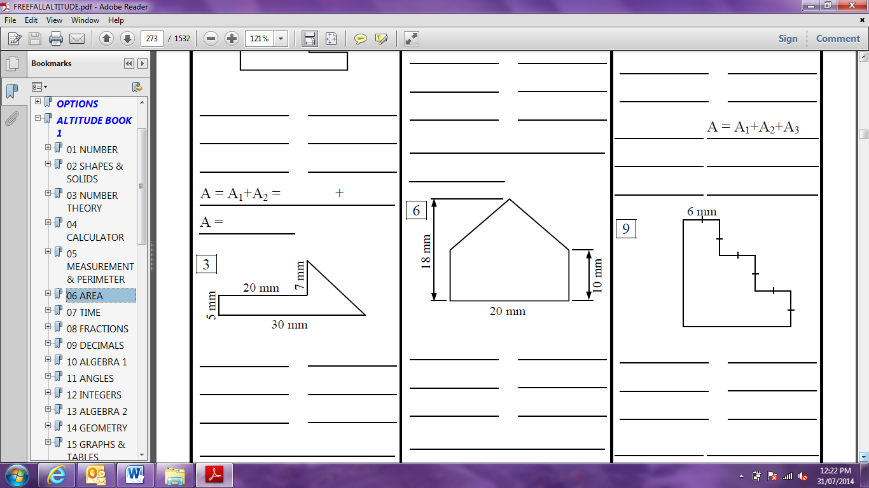

[3 Marks]

d.
10 cm
12 cm

[3 Marks]
- Find the length of the side of the square:

Area = 64 mm²

[1 Mark]

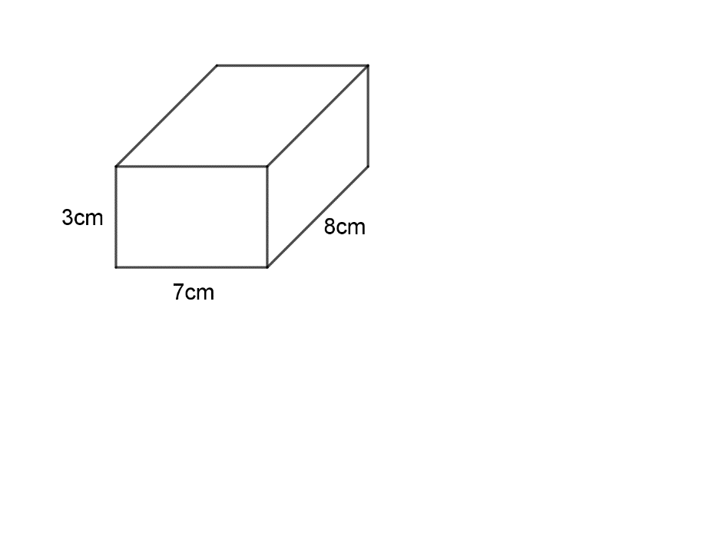
Question 3 8 marks
Find the surface area of each of the following prisms:

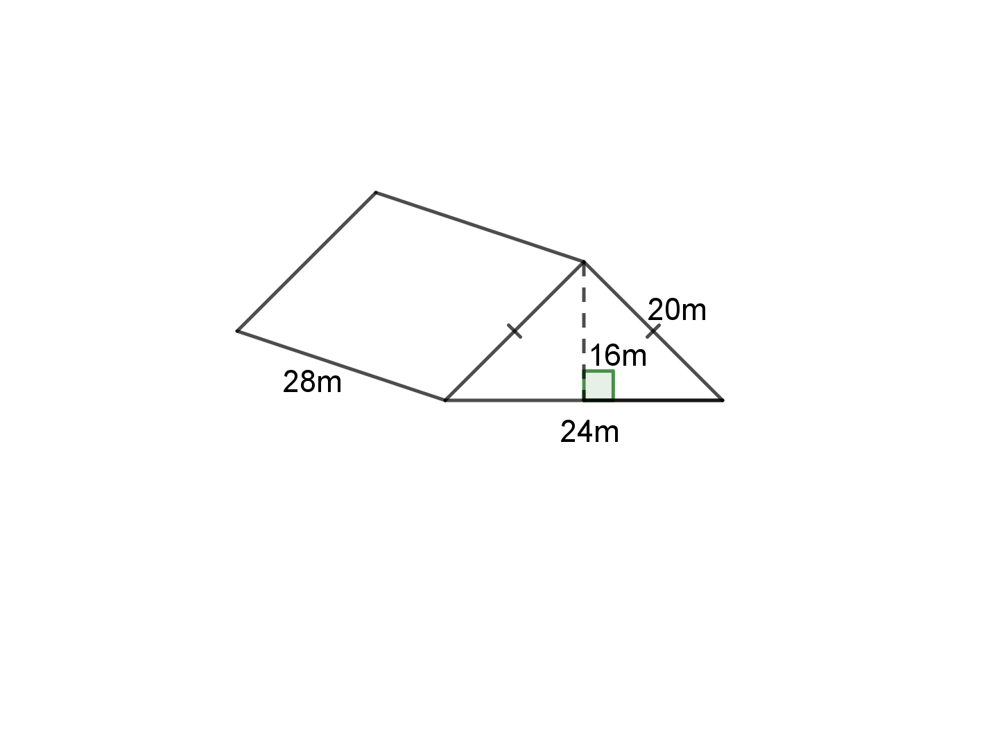

Question 4 3 marks
This diagram represents a new storage building.
Find:
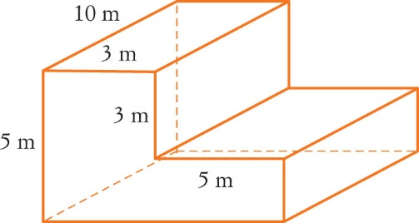
a the area of the front.

[2 marks]

b the volume of the building.

[1 mark]

Question 5 4 marks

A metal container is filled with water. It has a length of 0.8 m, width of 50cm and a height of 22cm. Calculate the amount of water that the can will hold.

Question 6 4 marks
A room has ceilings 250 cm high and is 5 m by 370 cm. Ignoring doors and windows, find the surface area of the walls and the cost of painting the walls at $14.50/m² .

